Appendix 1: Assignment submission cover sheet

ASSIGNMENT SUBMISSION COVER SHEET

Cse25-390
Student Id:

Student names:
Tshegofatso Patricia Relaeng
Student email:

Cse25-390@thuto.bac.ac.bw
Cohort: cse1-4

WMD Assignment Part A
Assignment title:

20 March 2026
Date of submission:
BSC Computer Systems Engineering

Programme of Study:

2026
Year of Study:

Intellectual property statement
By checking the box below, I certify that this assignment is my own work and is free from plagiarism. I understand that the assignment may be checked for plagiarism by electronic or other means and may be transferred and stored in a database for the purposes of data-matching to help detect plagiarism. The assignment has not previously been submitted for assessment in any other unit or to any other institution. I
have read and understood the Botswana Accountancy College plagiarism guidelines policy.
☐ Agree Signature………T.Relaeng………………………….
Date…20\03\2026……………………………………….
Page 6 of 6

WEBSITE OUTLINE
Panda Paradise is a clothing brand offering stylish and high quality clothing. It is a engaging and user friendly platform that allows customers to view, explore and purchase products online. Panda Paradise also offers easy navigation, personalized recommendations and convenience for customers by easy accessibility throughout all platforms.
GOALS AND OBJECTIVE
- Promote the brand
The website is created to show the brand identity and make it more visible to customers as a reliable fashion brand. This helps to build more trust, attract and encourage customers to support and buy from Panda Paradise.
- Promote sales
The goal is to encourage customers to make purchases using easy online platforms. This will help increase profits and allow the business to continue operating. Panda Paradise making sales will help the business improve and show it is reliable to customers.
- Provide information and ensure accessibility
Panda Paradise website will provide clear information to customers allowing accessible to everyone. Customers will be able to browse through the catalogue and make interaction with the brand at their comfort, anytime and anywhere. Informed decisions can also be made by the brand and customers after feedback from both parties.

TARGET AUDIENCE
- People from the ages of 12-35
- Both genders
- Fashion conscious and people who love trendy and street wear clothing

Demographics: They are people who utilise the internet and are active online shoppers making it easy to provide them with information from the website.

Technical aptitude: The website will be customer friendly with ease of access to enable utilization by customers with elementary technical skills.

TYPE OF WEBSITE
The website is a:

Multipage website
That has 7 pages namely:

Log-in(login.html)
Sign-up(signup.html)
Home(index.html)
About (about.html)
Catalogue(catalogue.html)
Contact(contact.html)
Feedback(feedback.html)
Profile(profile.html)

INFRORMATION DESIGN AND TAXONOMY

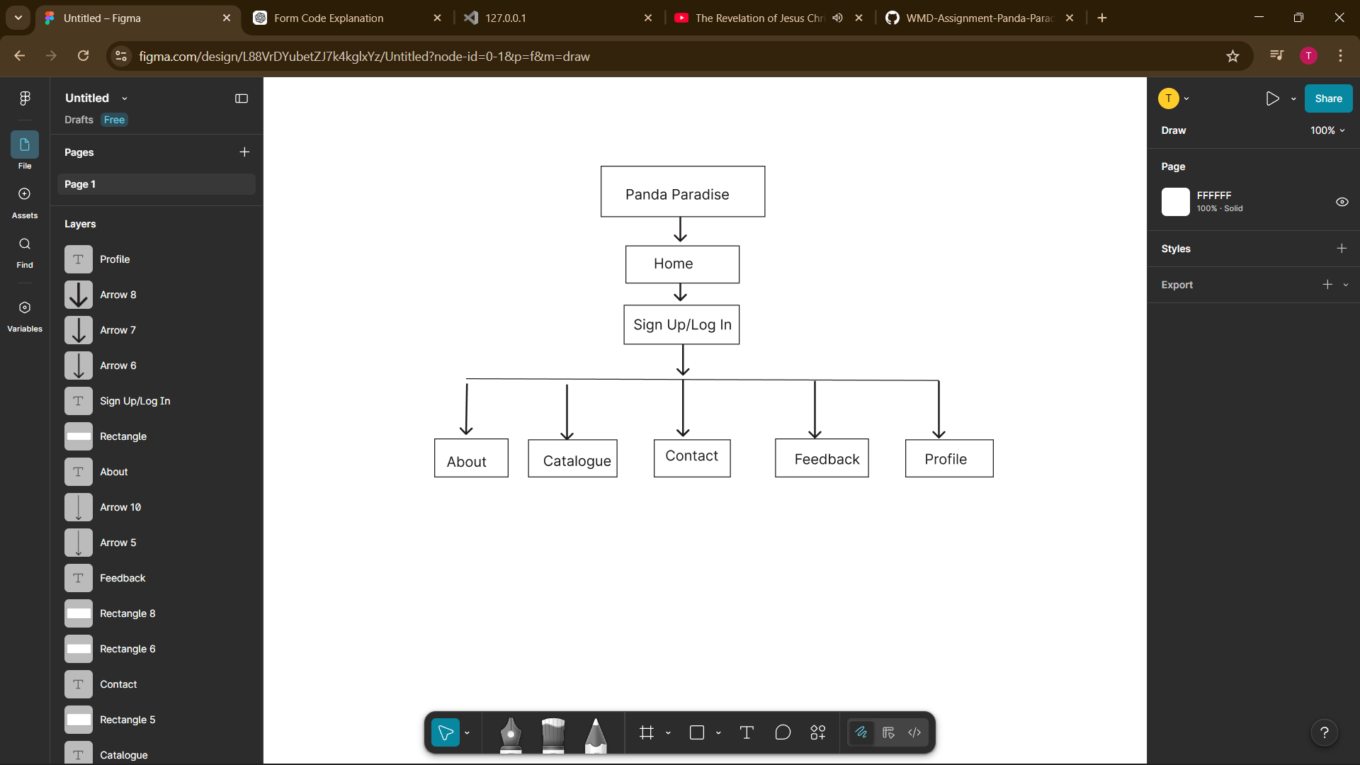

Sign-up: This page will require the customer to input their email address or phone number as well at the password to gain access to the website and utilize it.
Log-in: It will authenticate by prompting users to input their details so that only authorized people can access their accounts.
Home: The landing page has the welcoming message and a few products which have the option to shop now which leads to catalogue. It also has the services provided by Panda Paradise and the footer containing contact information, location and social media platforms. It also has all navigation.
About: It shows the story of Panda Paradise fully highlighting its mission, vision and values as a brand. Also gives way for customers to explore the fashion collections.
Catalogue: Showcases the products in their categories with full descriptions as well as prices. It also gives customers the path to shop and add products to their cart.
Contact: The page provides customers with information about the website. It also has contact details, location as well as links to the social media platforms of the website.
Feedback: Allows customers to give feedback and review products, helping new users to see and understand the website from other customers’ perspective. This also helps the brand owner to make decisions based on the feedback from customers and improve the brand.
Profile: This is where customers can view their account information and edit their profiles. They can navigate through their order history and manage their preferences

TECHNICAL BRIEF
- Html 5
- CSS
- JavaScript
- Bootstrap
- Microsoft Word
Tools
- Canva
- Figma
- VS Code
- GitHub
- Git Pages

PAGE TEMPLATE DESIGN
This is an overview of how Panda Paradise will look like once completed. It includes both high fidelity and low fidelity designs.
HOME PAGE
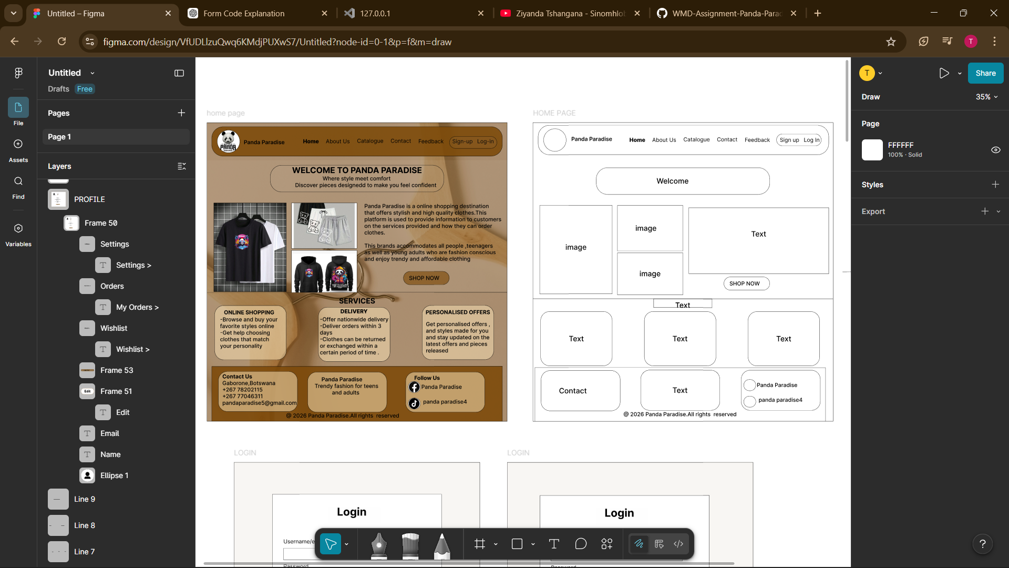
LOGIN
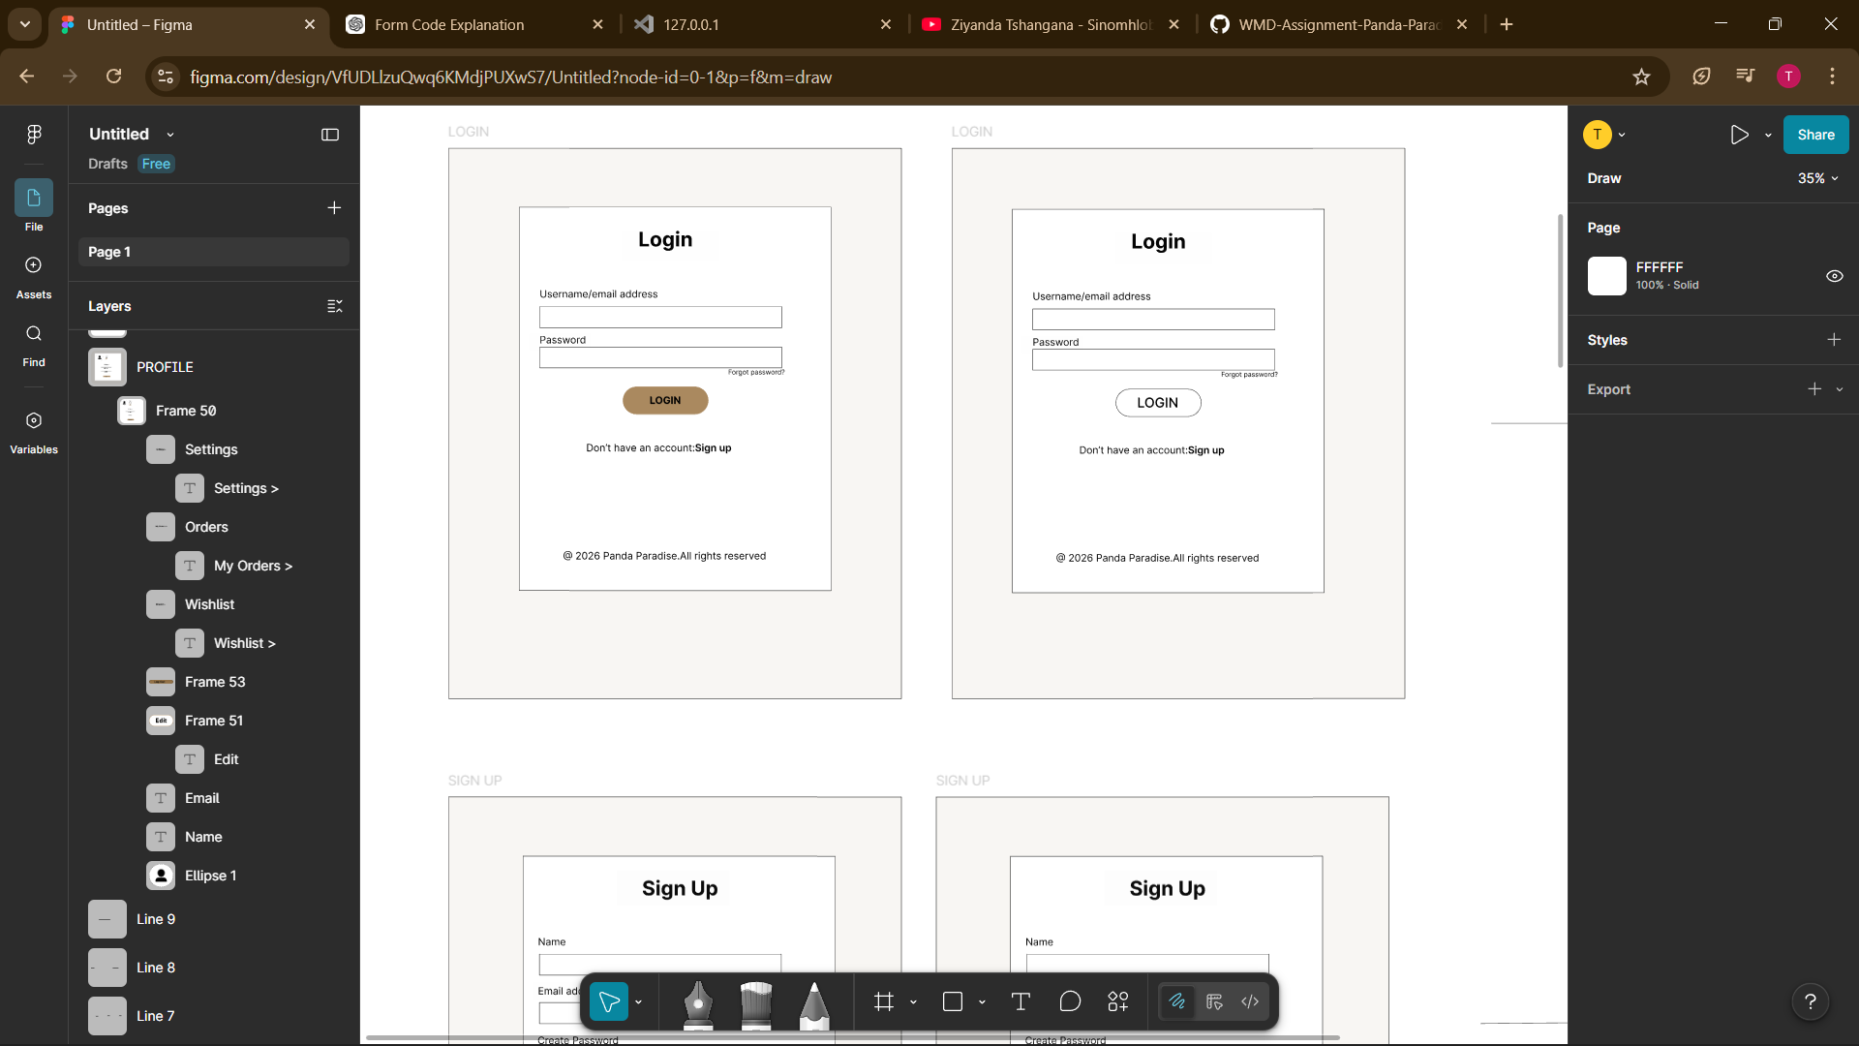

SIGN UP
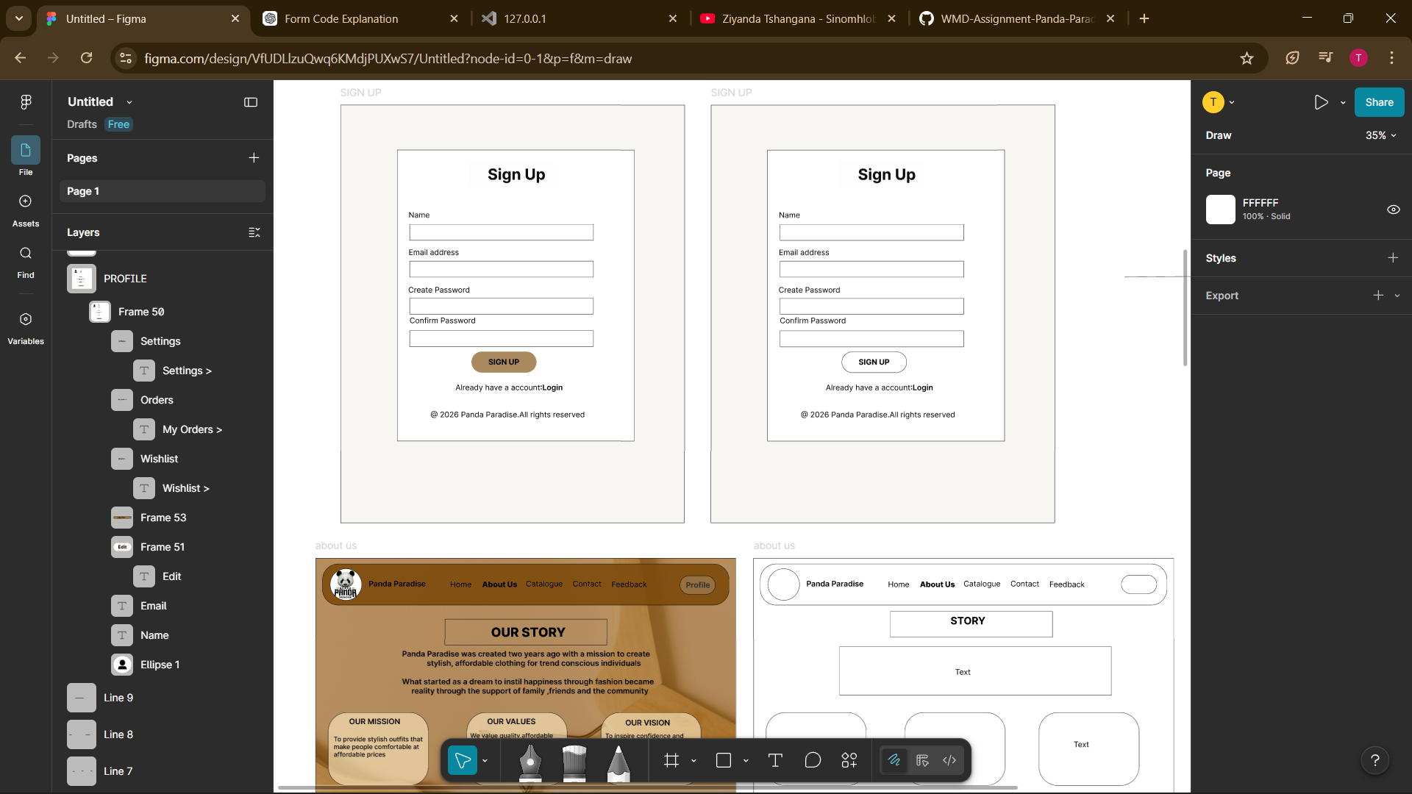
ABOUT US
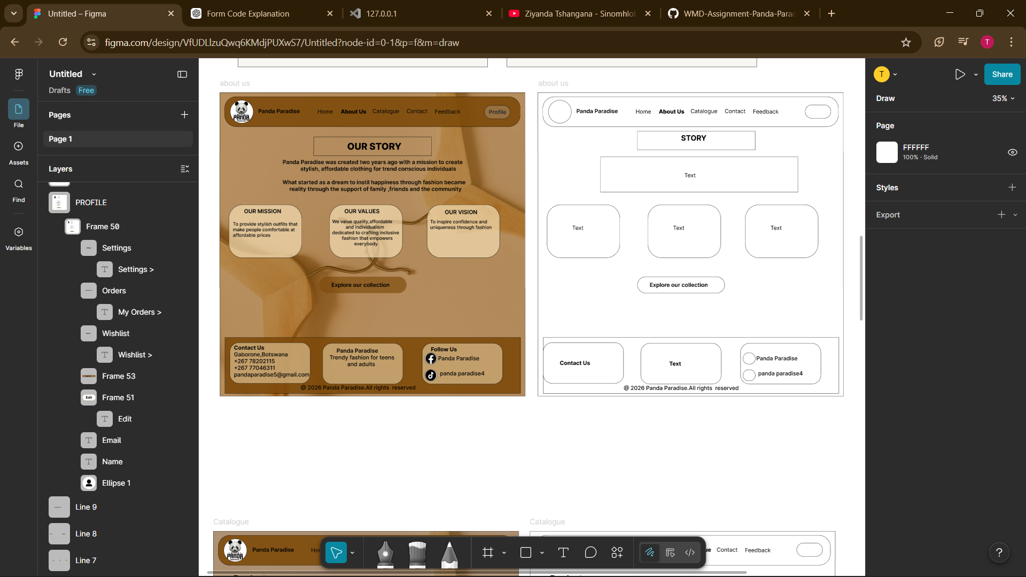

CATALOGUE
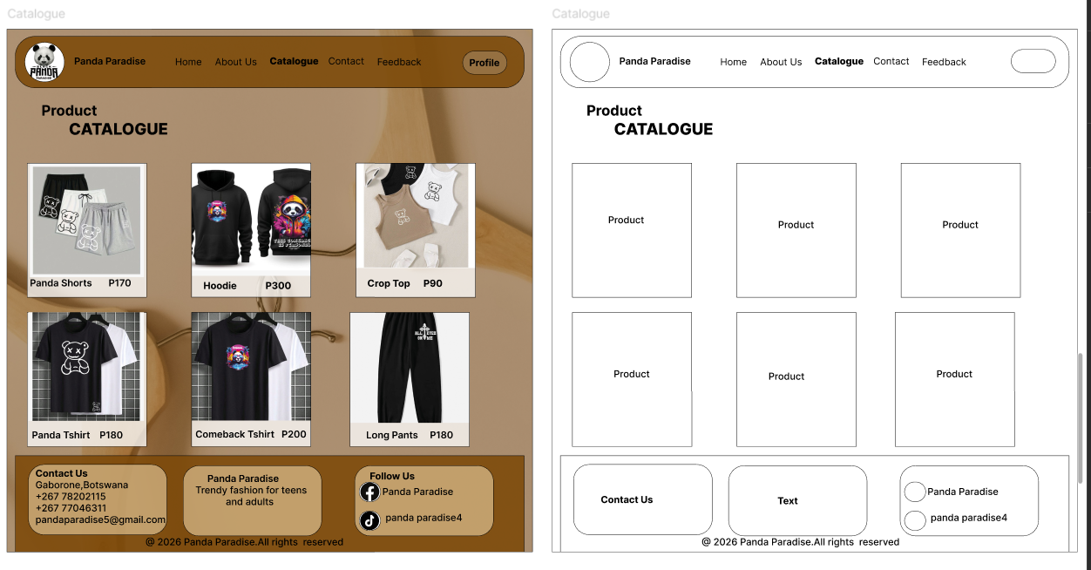
CONTACT
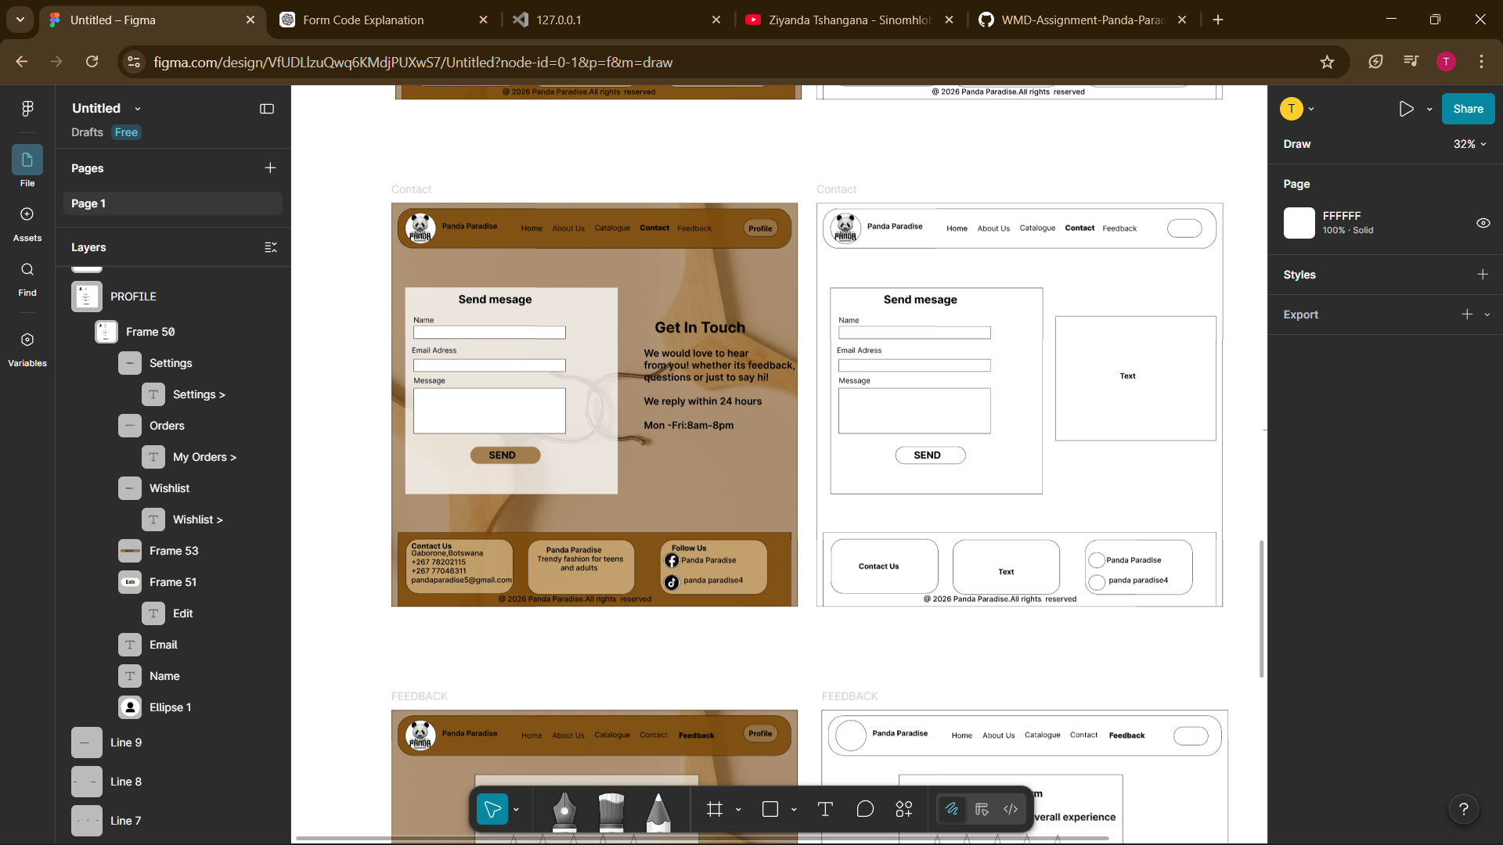

FEEDBACK
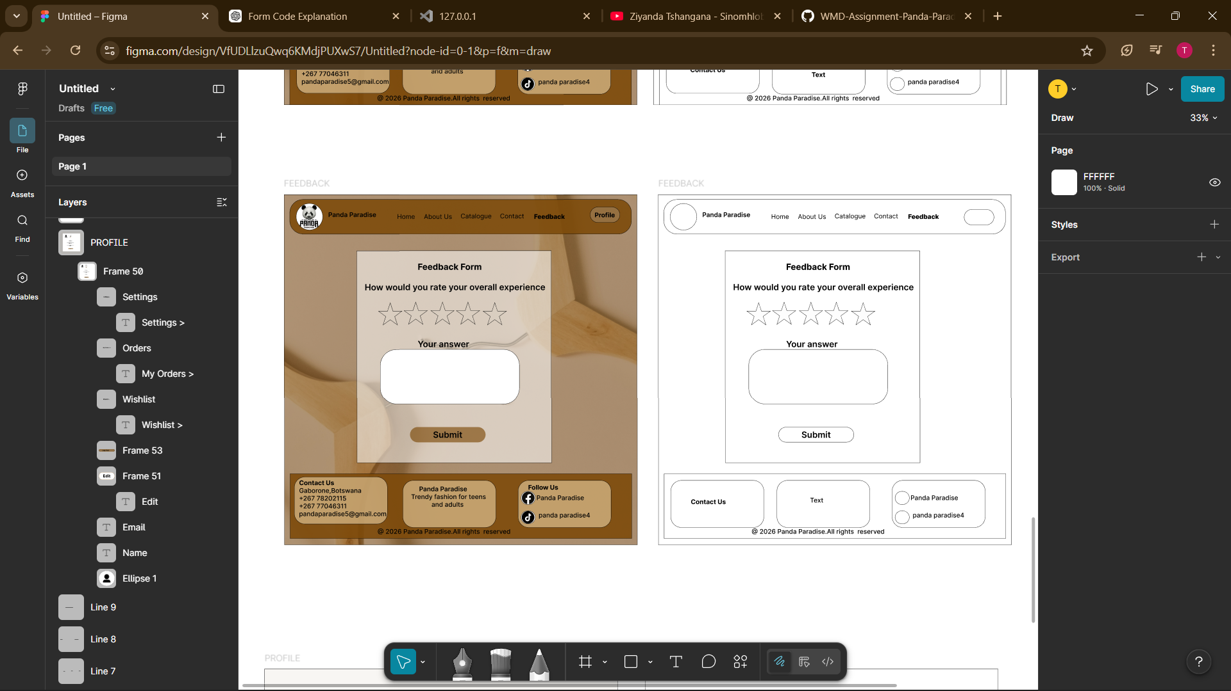

PROFILE
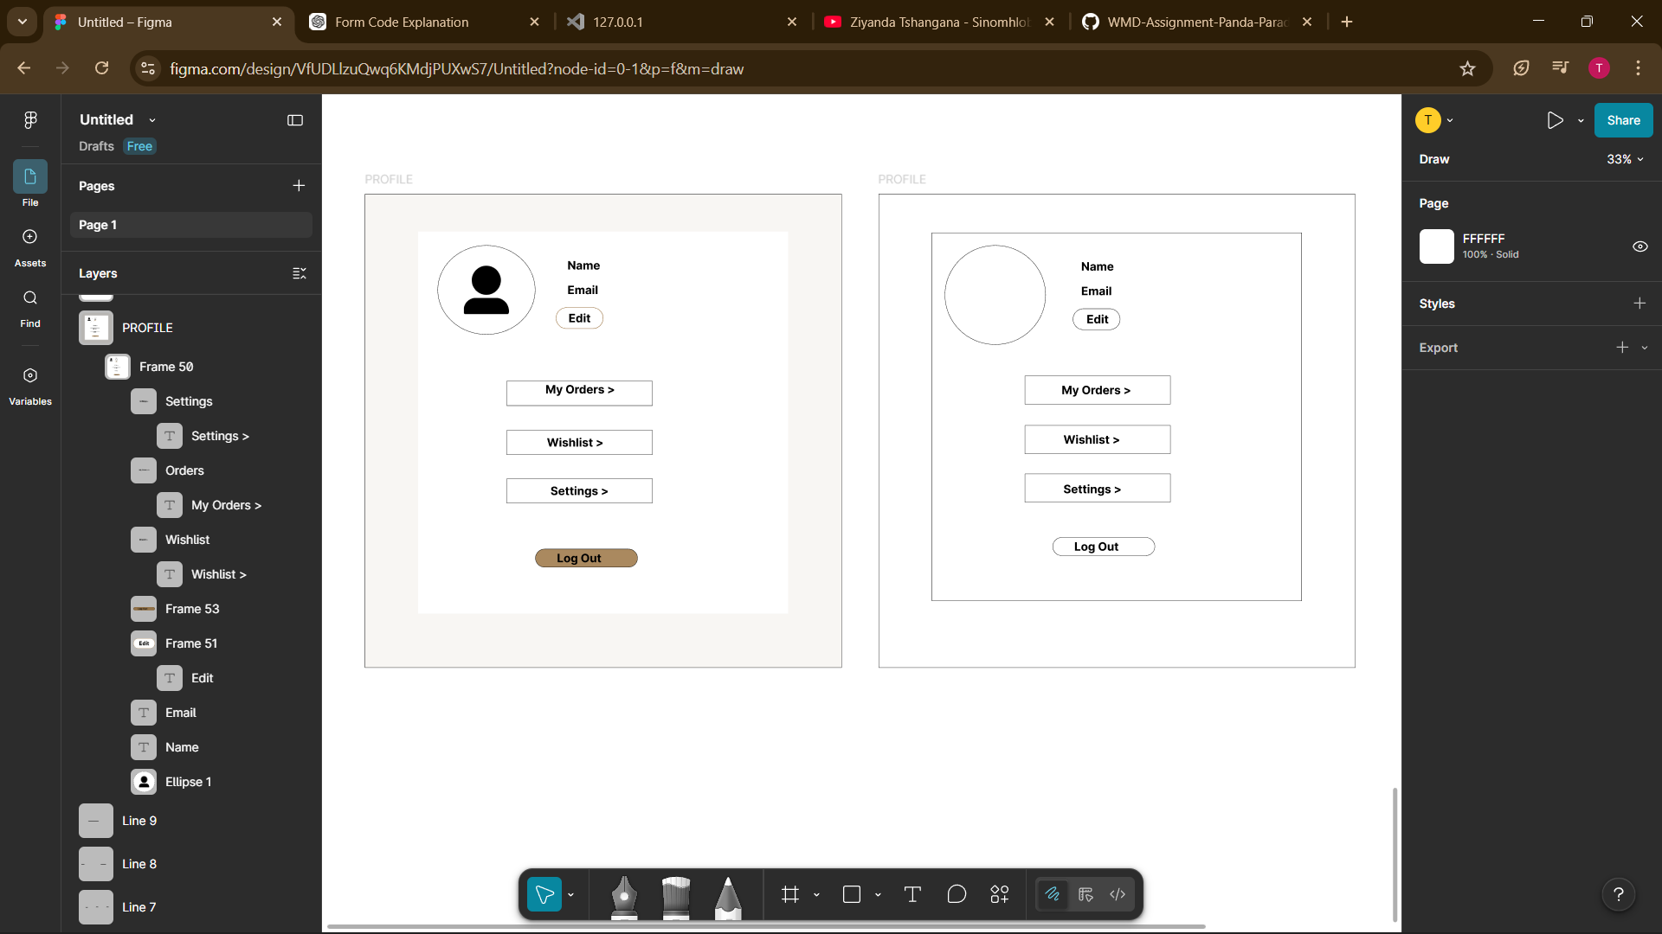

Dev mode link:https://www.figma.com/design/VfUDLlzuQwq6KMdjPUXwS7/Panda-Paradise-Website?node-id=0-1&m=dev&t=PkyrK2YNiy6CkOtg-1
Prototype link:https://www.figma.com/proto/VfUDLlzuQwq6KMdjPUXwS7/Panda-Paradise-Website?node-id=0-1&t=PkyrK2YNiy6CkOtg-1

